***EXPERIMENT NO.1 BASIC PROGRAM USING BRANCHING AND LOOPING***

Program of firstprogram:-

class firstprogram

{

public static void main(String args[])

{

System.out.println("hello world");

}

}

OUTPUT:-

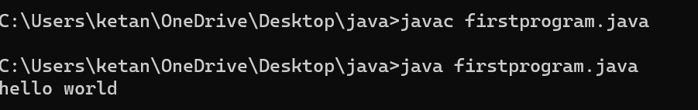

Program IF ELSE:-

class ifelse

{

public static void main(String args[])

{

int a=2;

if(a%50==0)

{

System.out.println("it is divisible");

}

else

{

System.out.println("It is not divisible");

}

}

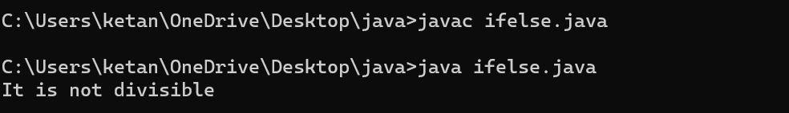

Program of NESTED IF:-

public class nestedif

{

public static void main(String[] args)

{

int age=25;

int weight=48;

if(age>=18)

{

if(weight>50)

{

System.out.println("You are eligible to donate blood");

}

else

{

System.out.println("You are not eligible to donate blood");

}

}

else

{

System.out.println("Age must be greater than 18");

}

}

}

OUTPUT:-

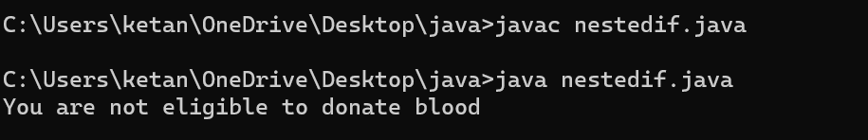

Program for loop:-

class loop

{

public static void main(String arg[])

{

int a=5;

for(int i=0;i<a;i++)

{

System.out.println("i");

}

}

}

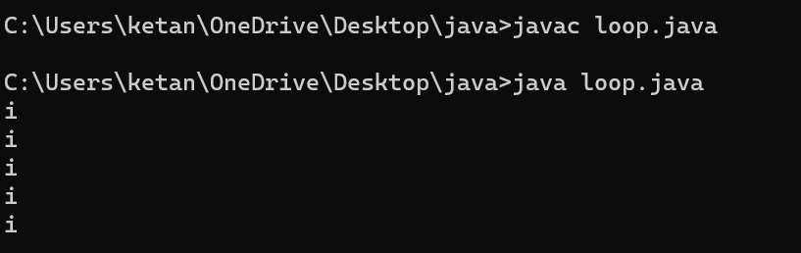

Program of Dowhile:-

class dowhile

{

public static void main(String args[])

{

int a=2;

do

{

System.out.println(a);

a++;

}

while(a<25);

}

}

OUTPUT:-

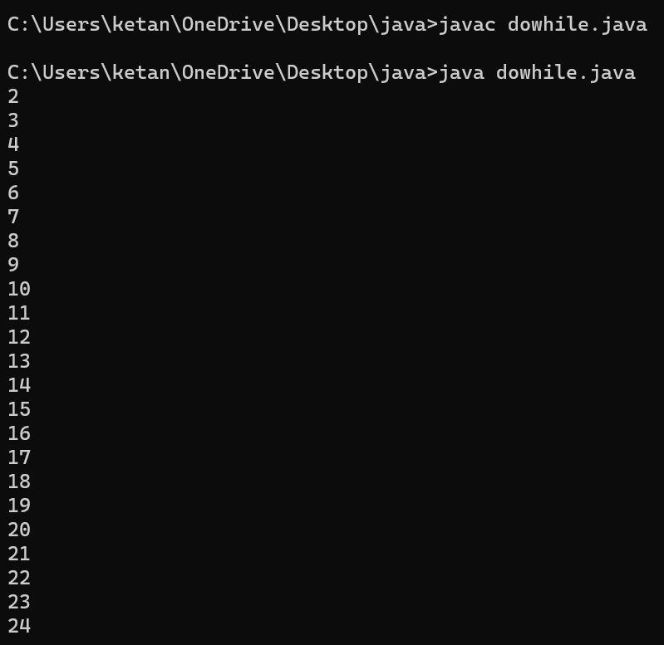

Program of While loop:-

class whileloop

{

public static void main(String args[])

{

int a=0;

while(a<10)

{

System.out.println(a);

a++;

}

}

}

